Step by step guide to register for patient access

- Go to www.patientaccess.com and select register. You can do this on a desktop, tablet or phone.
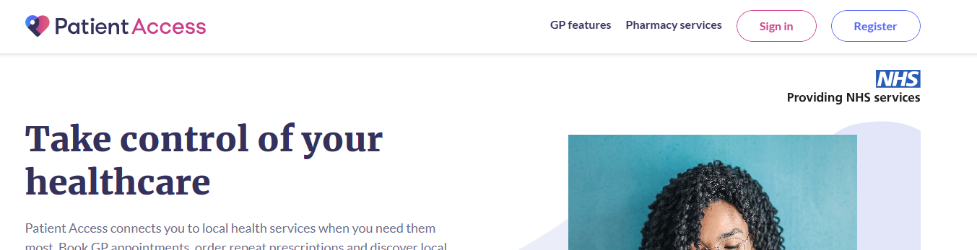
- You must now select ‘Continue to Create your account’. Do not choose Continue to NHS Login as this does not apply in NI
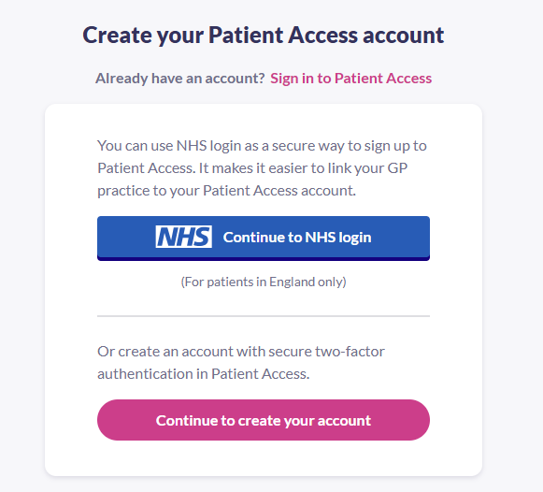
- Enter the required details
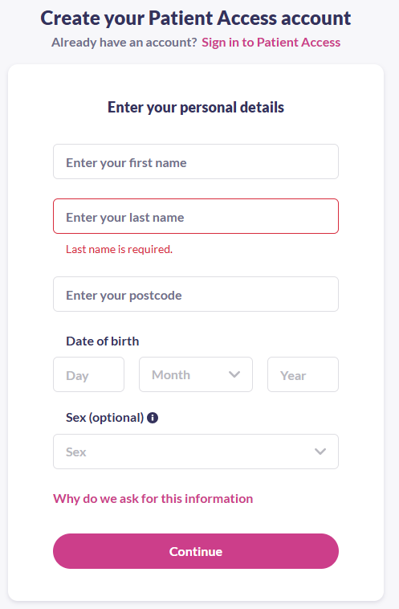
- Type in your email address and create a password. Accept the Terms & Conditions
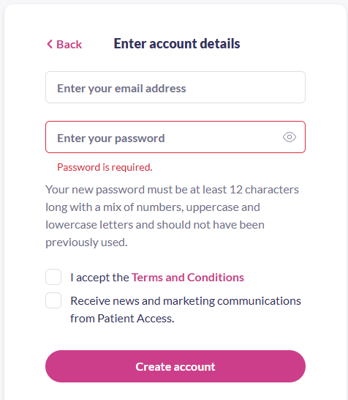

- Enter your mobile number, then click continue. You are now registered for online services
- You must now verify your email address. An email will be sent to your registered email address. You simply click on the link to verify
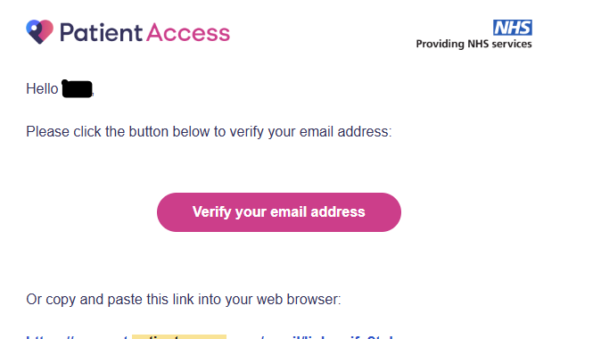

- At this point you will be asked to download an authenticator tool. This will generate a 6 digit code which you will use to log in. It is not required at every login. We find the Google Authenticator to be the most user friendly and it can be downloaded wherever you get your apps.

- Once you have downloaded your authenticator, you will need to ‘link’ it to Patient Access. This is not as complex as it sounds. You will be presented with the screen below
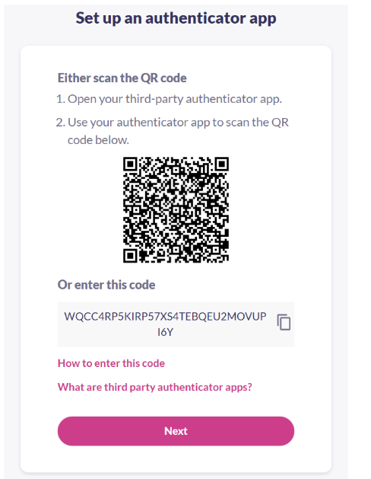
To enable the authenticator either use your mobile device and scan the QR Code or click on the icon that looks like two pages to copy the code. The mobile app will look like this
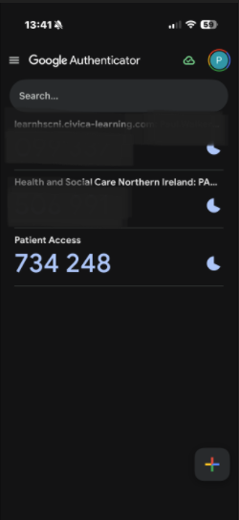
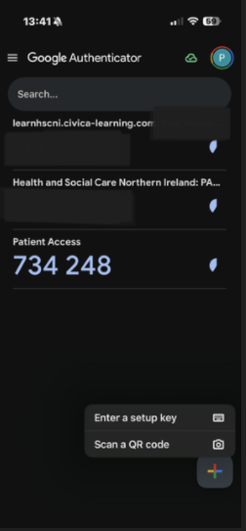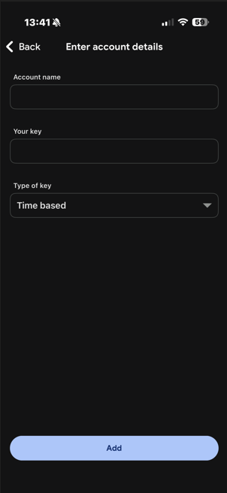
Click on the add symbol to add the code or use the QR code. If you choose to copy the code, you will be able to paste it into the enter account details screen.
Once the authenticator is setup, click next on Patient Access and enter the six digit code from the authenticator into Patient Access, then click verify
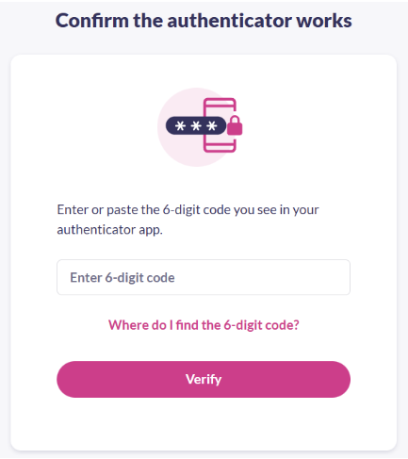

- The final step is to link your GP Practice. There are two ways you can do this. You can email Registrations.Priory.Z00252@gp.hscni.net and we will send you your registration letter with applicable codes, or you can call into the Practice and we will be able to print the letter for you. Then simply follow the steps below to finish the process.
